Table 2:

**Also for Child-Pugh score, I don’t understand what is “Normal”? If this denotes patients without cirrhosis, then this should be mentioned as “Non-cirrhotic”. If some patients did not have Fibrosis assessment by Fibroscan (it became available very late in some centers), but had a liver biopsy (The Ludwig histological classification) then we can lump Fibroscan categories of F0-2 with The Ludwig histological classification “stage I and stage II together, and the same for F3-4 and Ludwig Stage III and IV. This we can mention in the methodology for clarification. Hence, when tabulating the “Child Pugh score” we can combine F4 or Fibroscan with Stage IV of Ludwig classification, if there is missing Fibroscan score for any of the patients. As such, it would be best to show the data within 3 rows: F0-2 (this would be only by Fibroscan or biopsy), F3-4 (also only by Fibroscan or biopsy), and decompensated stage Child Pugh 7-15. The comparison between responders and non-responders should have be comparison between these 3 different stages of liver diseases. I hope this is clear (if not then I can explain in a meeting**

**HM30JUL2024The table was made exactly as per the comments provided on 9th June 2024 (please refer to the comments provided before), So what is required now is out of the scope of those latest comments.**

**I am not sure I can get what is needed now, and I feel it needs dataset update before rerunning the analysis.**

**Table3:**

**Incomplete: I’m not clear on one thing. There is a clear discrepancy in the table below in the variable “Fibroscan findings” where 32 patients had missing values only and in the “Fibrosis score” variable which shows 131 patients had “NA” which I assume means “Not applicable or Not available”. While I intend to take out completely the variable “Fibroscan findings” which is a waste of time, I want to understand why you have this discrepancy. Please clarify.**

HM30JUL2024: As per the provided dataset,131 patients has the value of “NA” and 9 has missing for fibrosis score at 1 year FU. For fibroscan findings at 1 year FU, 32 patients are missing.

If those results are not plausible, then those are data issues not analysis issues and dataset will need update.

Need a table (table 7) to list the baseline variables who **received OCA** and showed response vs those who showed no response. The variables included should be all those included in the baseline table, sub analysis of patients on OCA will be added, check the total number of tables requested in gastroenterology journal

**Incomplete: Please clarify the total number of patients who were prescribed OCA? In this patients who took OCA, I want to know how many responded at “end of follow up”. It would be useless putting this in a table as the number is very small and this was not a stated objective of the protocol.**

HM30JUL2024:As shown in the table, 16 patients received OCA. At end of FU, 8 were responders and another 8 were non responders.

**14.KM curve:**

**Incomplete: Please clarify what was done for the KM analysis below? I don’t think it is a “survival probability” given the data of mortality mentioned earlier. On the other hand, it is possible that this represents a composite endpoint of either a decompensation event (ascites, variceal bleed, encephalopathy, HCC or death) in the 2 category of patients – responders at 1 year vs non-responders at 1 year. If this is what has been done (please confirm number of events as discussed in earlier pages) then change the legend of the “Y axis” and perhaps label it as “Probability of decompensation”. Otherwise please clarify**

**HM29JUL2024**

**As required by you, a composite end point was derived based on occurrence of any of decompensation event (ascites, variceal bleed, encephalopathy, HCC or death).**

**Number of events (please see the updated figure below).**

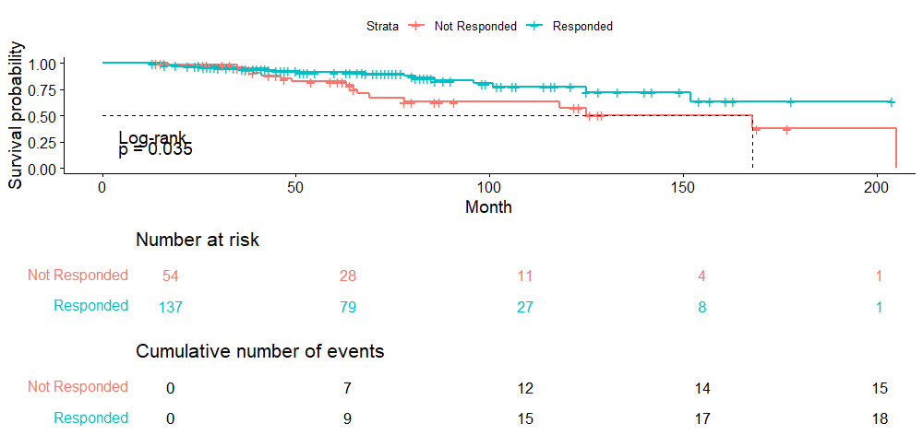

**Survival is a generic term to indicate the proportion of patients who haven’t experienced the event at timepoint. As you can see, the survival probability decline with time as patients continue to experience the event. So, Probability of decompensation is a wrong word and probability of survival is the correct term to use.**

11.Multivariate analysis of survival, LT, or liver decompensation (ascites, PSE, variceal bleeding, HCC) in a separate table (table 4) will be added

**Incomplete:**

1. **I believe that we have to remove Child Pugh 7-15 patients (at baseline) as they are already having decompensation at baseline visit. In addition, is this multivariate analysis a composite end-point that you have ascertained? By composite end-point, I mean whether we identified the patients who had either death (I don’t think any of the patients died as per table on page 9, but this needs to reconciled with the table on page 22 where it shows that 2 patients died), or LT, or liver decompensation (ascites, encephalopathy, variceal bleeding, HCC) at any time point in the study? So, in this regard, a patient who has variceal bleeding and also develops HCC should be counted as just one patient. I just want to be sure we are on the same page…**

**HM30JUL2024: The multivariable cox regression is made according to the composite end point that was derived (see details above) so that if the patient experienced any of the decompensation criteria, then he/she considered to have an event.**

1. In addition, please refer to my attachment of June 3 where I have mentioned the following also needs to be done: In addition another variable Responders vs non-responders at time points 1 year and also at time point end-of-follow.

**HM30JUL2024: when this variable was added to the model, it led to conversion failure (i.e biased and implausible estimates) so it is not feasible to add this variable.**

1. **Can we use age <40 and age >40 at diagnosis as an additional variable to see if this was significant for this analysis?**

**HM30JUL2024:Out of scope of June comments, to be updated**

1. **I would really like to see patients categorized into those who had a composite endpoint vs those who did not have a composite endpoint (as I showed in my email on June 3 as inserted partial table). This would constitute a univariable analysis perhaps but appears better to the reader.**

**HM8August2024:The table is already comparing the hazard ratio of having composite end point vs not having the endpoint.   
Please send a structure for the table you need as it is not clear what do you meant by “patients categorized into those who had a composite endpoint vs those who did not have a composite endpoint”**